Mobile Crane Operations

Mobile Crane Operations at Multi-Cargo, Port of Auckland.

**Crane Operations at Port of Auckland**

This document outlines the requirements that need to be met in order to gain approval to enter the Port and carry out crane operations.

**Requests for Operations**

All requests for crane lifts are to be sent by email to Multi-Cargo mcops@poal.co.nz, using an application form provided by Port of Auckland. The application form must be submitted at least 36 hours prior to the operation. (Appendix 1).

Upon receipt of the application and based upon the information supplied and the applicable operational space on the wharf at the time, the application will be approved or alternative arrangements may be made.

**Safety Requirements**

1. **All lifts (tonnage) must comply with the Port of Auckland Single Axle Safe Loadings limits** for maximum axle loads as determined by Port of Auckland Infrastructure and Engineering. (Appendix 2).
2. Appendix 2 also shows a plan of the wharves and acceptable single axle loading across them.
3. Appendix 3 shows the maximum Outrigger/Spreader Beam Load for the various wharves as well as the maximum single axle load anywhere on each wharf.
4. All workers involved with and operating a crane within the POAL must comply with the WorkSafe NZ, Approved Code of Practice for Cranes, 3rd Edition, 2009. This information can be found at www.worksafe.govt.nz/worksafe/information-guidance/all-guidance-items/acop-cranes
5. Port of Auckland have a Health and Safety Policy which requires all PCBU's requesting access to the Port to have completed a POAL Accessing the Port Induction, and a Transport Operator Induction, which must be completed prior to an access card being issued. Access can be granted to non-inducted people under the POAL visitor procedure. The Inductions cover:
   * Port Entry and Evacuation
   * Hazard Management
   * Policies and Procedures
   * Port Road User Rules
   * Environmental responsibilities
6. In addition, all users are required to adhere to all safety regulations when operating their cranes on POAL.
   * Areas where crane work is being carried out must be cordoned off and signs erected warning other people of the activities of the licensed crane company
   * All equipment and plant used for cargo handling must have current warrants of fitness
   * All equipment and plant used for cargo handling must be removed from the worksite (as defined in the Crane Permit) immediately after completion of the task to allow other port users unobstructed access and use of operational areas
   * All vehicles entering the POAL require a flashing amber safety light on the vehicle. Vehicles hazard lights are not accepted for this safety protocol.
7. PPE equipment must be worn in accordance with the following standards:
   * Fall protection equipment (Harness) as required for the tasks and designed for that purpose
   * Safety Footwear, appropriate to the tasks assigned to the worker, approved to AS/NZS 2210.3
   * High Visibility Vests or Clothing as required for the tasks, equivalent or approved to AS/NZ 4602.1
   * Safety Helmets, approved to AS/NZS 1800.1:1998 Occupational safety helmets – Selection, care, and use, AS/NZS 1801:1997 Occupational safety helmets
   * Protective Gloves appropriate to the tasks and shall be worn where there is the potential for hand injuries
   * Hearing Protection, approved to AS/NZS 1270, to be worn by all personnel where there are significant noise hazards
   * Respiratory Protection, approved to AS/NZS 1716, 1715, and shall be worn where there is the potential for airborne contaminants to be inhaled and the associated canisters designed specifically to provide the protection for the substance. Minimum protection is P2 Standard Respiratory Protection.
   * Safety Eye Protection, approved to AS/NZS 1337, shall be worn by all personnel where there is the potential for a foreign object or substance to enter the eye and cause injury

**Security**

The Port of Auckland is a NZ Customs controlled area, therefore all port users must comply with all POAL security procedures and requirements.

A list of all personnel involved with the crane operations must be provided within the 36 hours (listed on the application form) to the POAL team for distribution to First Security who control access to and from the Port. Failure to provide this denies the user access to the Port. All personnel must supply photo I.D on arrival to the Port.

**Inspection and Evaluation**

The Crane Company and/or operator are to provide a Safe Work Method Statement (Please refer to application form). This will include a description of the job, lift plan, outrigger loads, hazards, risks and mitigations.

Each application is to specifically detail each Crane Operation/lift, One application, one lift.

Should a crane company wish to undertake a new lift, they will need to apply for another permit.

**Operating License**

All Crane Companies are required to hold a current POAL Operating License, have applied for and been granted a POAL Credit Account and have agreed to POALs Authority To Work to work at Port of Auckland.

**Permit Fee**

The Crane Lift Permit charges are subject to annual review and can be found on our public tariff located here http://www.poal.co.nz/shipping_cargo/price_schedule/

See attached table:

|  |  |  |  |
| --- | --- | --- | --- |
| **Number of Cranes** | **Number of lifts** | **Number of applications** | **Applicable fee** |
| 1. 1 crane | 1 lift | 1 application | Crane lift Fee |
| 1. 1 crane | several lifts | several applications | Crane lift Fee |
| 1. 2 cranes | 1 lift (twin) | 1 application | Crane lift Fee |
| 1. 1 crane | several lifts per 8hr Period | 1 application | Facility Fee |
| *The above (no:4) is in cases such as the frozen fish where the crane is setup in one location* | *lift cargo of similar weights per lift for the same consignee* | *Seek clarification of lift fee from POAL for unique lifts* | *All fees can be updated each financial year (Port discretion)* |

**Annual Insurance**

The user is required to provide an annual public liability insurance policy with a reputable insurance company, insuring the user’s liability for loss or damage to third party property or injury to persons arising out of the ownership or use of the Crane that is the subject of this agreement. (Refer to Crane Operating Licence for cover levels)

**Crane Lift Restrictions**

Swing lifts and Hiab lifts are prohibited on any POAL property unless specially authorized by the POAL Team.

**Appendix 1**

Application Form - Mobile Crane Lift Operation

**Date & Time of Lift:** **Estimated Duration:**

**Location:**

**Operator Contact Information**

|  |  |
| --- | --- |
| Crane company: | PO #: |
| Contact person: | Phone #: |
| Crane Operator: | Operator Phone #: |
| Dogman: | Dogman Phone #: |

**Additional Contact details (as required)**

|  |  |
| --- | --- |
| Stevedore Contact: | Ph. #: |
| Transporter Contact | Ph. #: |
| Alternative Contact: | Ph. # |

**Pre-Approval (POAL)**

|  |
| --- |
| Status: Pre-Approved Declined |
| Location: |
| POAL Name and Signature: |
| Date Authorised: |
| Further Instructions for the Lift: |

**Sign Off (Crane Company)**

***I understand this application (if approved by POAL) is Pre-Approved only and the Crane Operator must ensure Final Approval is sought from Multi-Cargo staff prior to setup of the crane.***

|  |  |
| --- | --- |
| Name: | Signature: |

**Cargo information**

|  |  |
| --- | --- |
| Cargo to be lifted:  *(incl Cargo weight)* |  |
| Lift plan attached for area: | YES NO |
| Please circle: | IMPORT EXPORT |
| Vessel: |  |

**Crane information**

|  |  |
| --- | --- |
| Equipment/Crane Type: |  |
| Type of Lift: |  |

|  |  |  |  |
| --- | --- | --- | --- |
| Outrigger | Maximum Load,  During Lift  (tonnes) | Location of Outrigger  e.g. on wharf deck, beam, pile cap or hard fill | Spreader beam details if used, eg “3 x 250mm x 250mm x 50mm thick hardwood packer per outrigger/pile.” |
| Quayside Front of Crane |  |  |  |
| Quayside Rear of Crane |  |  |  |
| Landside Front of Crane |  |  |  |
| Landside Rear of Crane |  |  |  |

**POAL Approval *(to be signed on the day of the lift)***

|  |
| --- |
| Status: Approved Declined |
| Confirmed Location: |
| POAL Name and Signature: |
| Date Authorised: |
| Further Instructions for the Lift: |

***Crane Operators must ensure Final Approval is sought from Multi-Cargo staff prior to setup of the crane (daily approval required if the lift is being performed over multiple days).***

|  |
| --- |
| ***Hazards*** |

|  |  |  |  |  |  |  |
| --- | --- | --- | --- | --- | --- | --- |
| **Description: hand protection**  Gloves | **Description: dust mask**  Face Masks | **Description: safety goggles**  Eye  Protection | **Description: face shield**  Face Shield | **Description: foot protection**  Appropriate  Footwear | **Description: hearing prot**  Hearing Protection | **Description: safety apron**  Protective Clothing |
|  |  |  |  |  |  |  |

|  |  |  |
| --- | --- | --- |
| ***Static Hazard*** | ***Risks*** | ***Controls*** |
|  |  |  |
|  |  |  |
|  |  |  |
|  |  |  |
|  |  |  |
|  |  |  |
|  |  |  |
|  |  |  |
|  |  |  |
|  |  |  |
|  |  |  |
|  |  |  |
|  |  |  |
|  |  |  |

**Appendix 2**

**Port Plan - Single Axle Safe Loading**

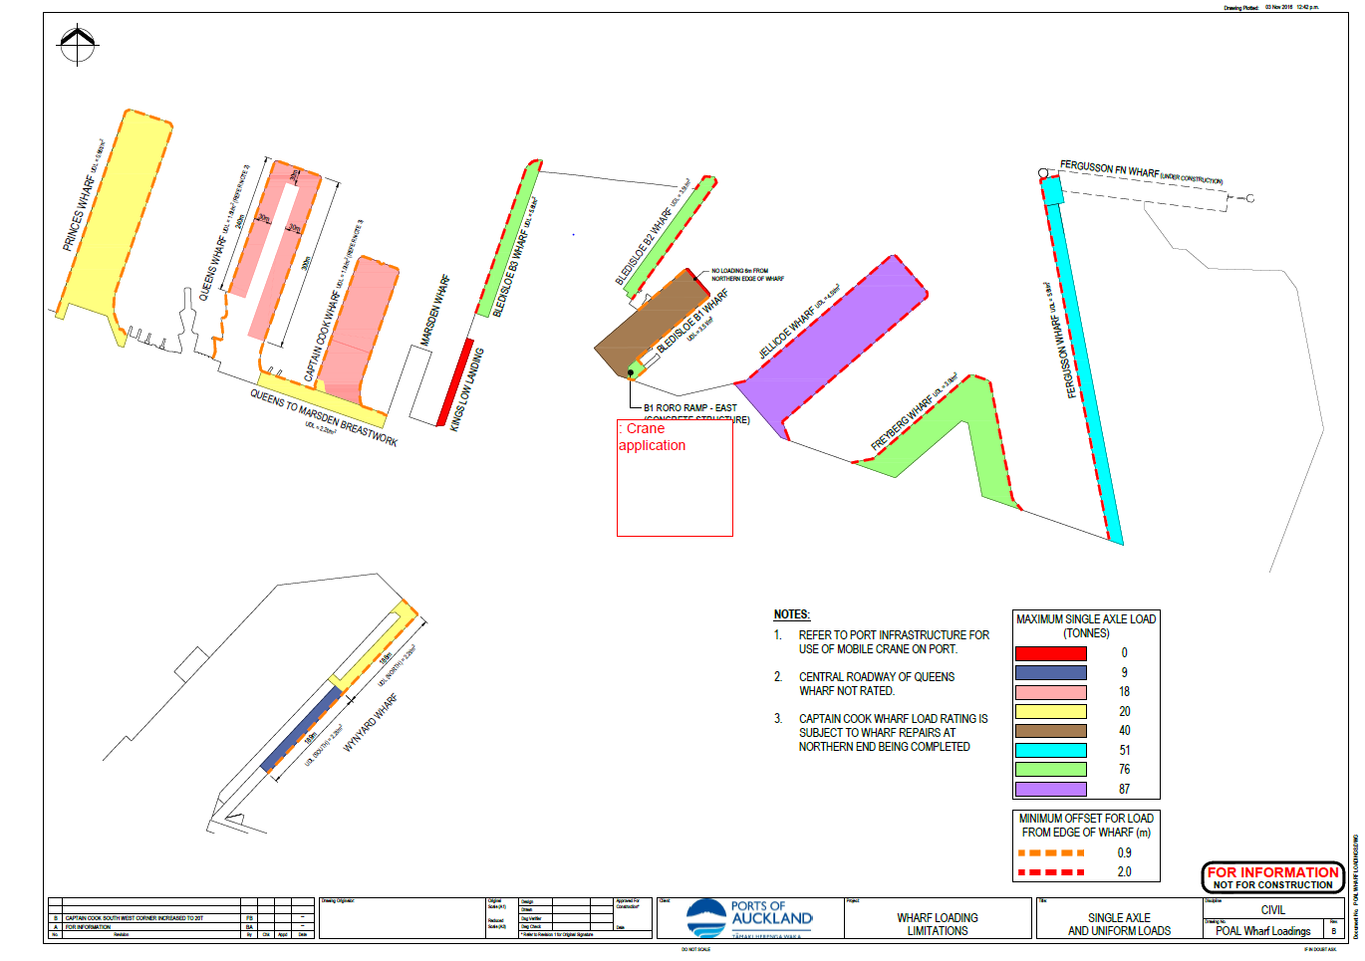

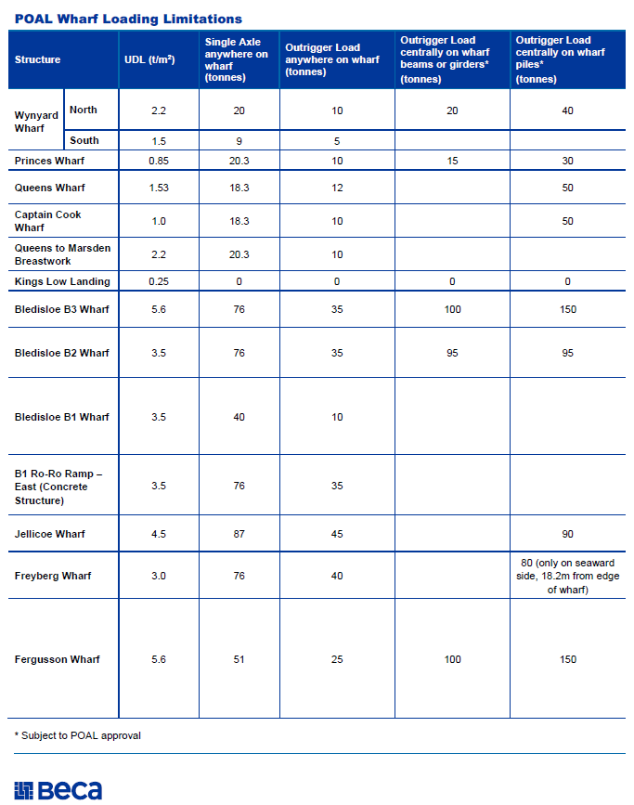**Appendix 3**